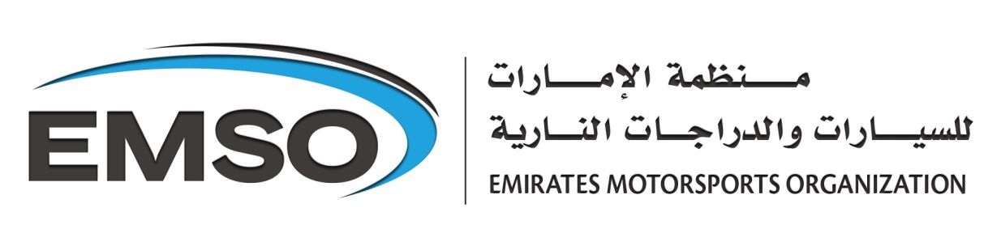

**Products and Service List for Technical Department**

**Motorsports Services**

* Roll Over Protection sticker issuance **25.00 AED**
* Pre-Approved Roll Over Protection Certificate & Declaration (One time issuance) **75. 00 AED**
* EMSO-UAE ASN Roll Over Protection Certificate (Approved ROP manufacturers only) **750.00 AED**
* FIA Roll Over Protection Certificate (Approved ROP manufacturers only) **1500.00 AED**
* New Technical Passport issuance **500.00 AED**
* Replacement Technical Passport issuance **1000.00 AED**
* Renewal of the Vehicle Registration NOC Letter **400.00 AED**
* FIVA Identity Card issuance + vehicle inspection **1000.00 AED**
* FIVA Yongtimer Registration Card issuance + vehicle inspection **1000.00 AED**

**Technical Services**

* Emission Euro 4 Drive Cycle Compliance Certificate **1000.00 AED**
* Emission 5 gas analyzer **(Petrol)** idle test **300.00 AED**
* Emission 5 gas analyzer **(Diesel)** idle test **500.00**
* Emission 5 gas analyzer **(Petrol)** idle test **off-site**  **500.00 AED**
* Emission 5 gas analyzer **(Diesel)** idle test **off-site**  **750.00 AED**
* Brake Test + Alignment Side Slip test **200.00AED**
* Corner weighting of vehicle **150.00AED**
* Exhaust Sound (Db) measurement testing (testing to ASE or customer specified standards) **150.00AED**
* Chassis Dynometer w/certified power certificate **500.00 AED**

**Note**: Price do not include VAT.